**🎯 Activity 2: 🔍 Hotspot Click – “Explore the Atom”**

🎙️ **Activity Introduction** 🎤  
“Atoms are tiny but full of important parts. In this exploration, click different zones on an atom to uncover what happens in each one. Discover where electrons zoom, and where protons and neutrons stay. Are you ready to dive inside an atom? Click to explore!”

**Learner Instructions (On Screen)**  
Click on the atom’s parts to reveal what each region contains and what role it plays.

**Media Tags**  
• [🎞️ Static atom diagram with clickable zones]  
• [🎞️ Labels: Nucleus, 1st Energy Level, 2nd Energy Level]  
• [🎨 Optional: Glow-on-hover or pointer icon for clickable regions]

**Hint (On Screen)**  
• The nucleus is in the centre.  
• The first energy level is closest to the nucleus.  
• The second energy level surrounds the first.  
Remember:  
• Protons and neutrons are in the nucleus.  
• Electrons live in energy levels.

**Developer Guide**  
• Use a high-resolution atom illustration with at least 3 interactive hotspots:

1. 🧠 Nucleus (centre)
2. 🌀 First Energy Level (inner orbit)
3. 🌀 Second Energy Level (outer orbit)  
   • When a learner clicks a zone:  
   o Display a fact box (positioned beside the hotspot)

**Activity Content (Hotspot Interactions)**

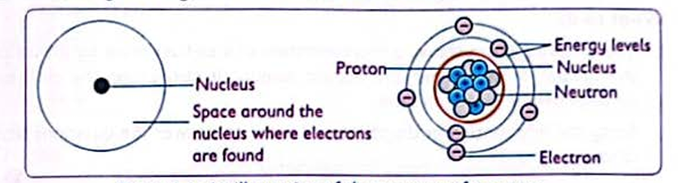

|  |  |
| --- | --- |
| **Hotspot** | **📖 Pop-up Text** |
| 🧠 Nucleus | “This is the core of the atom. It holds positively charged protons and neutral neutrons.” |
| 🌀 1st Energy Level | “This level can hold up to 2 electrons. These electrons spin close to the nucleus.” |
| 🌀 2nd Energy Level | “This shell can hold up to 8 electrons. It is farther from the nucleus than the first.” |

🎙️ **Activity Conclusion** 🎤  
“You have successfully uncovered the atom’s hidden zones. Remember, protons and neutrons stay in the nucleus, while electrons zoom around in energy levels. Great exploring!”